2015年（1月、6月）浙江省普通高中学业水平考试标准

英 语

浙江省教育考试院 编制

考试性质与对象
浙江省普通高中学业水平考试是在教育部指导下，由省级教育行政部门组织实施的全面衡量普通高中学生学业水平的考试。其主要功能是引导普通高中全面贯彻党的教育方针，落实必修课程教学要求，检测高中学生的学业水平，监测、评价、反馈高中教学质量。考试成绩是高中生毕业的基本依据，也是高等院校招生录取和用人单位招聘的重要参考依据。
高中英语学业水平考试标准根据教育部颁布的《普通高中英语课程标准（实验）》和《浙江省普通高中学科教学指导意见·英语（2012版）》和现行《普通高中课程标准实验教科书·英语》的必修教学要求，结合学业水平考试的性质和特点制定而成。
高中英语学业水平考试实行全省统一命题、统一施考、统一阅卷、统一评定成绩，每年开考2次。考试的对象是在浙江省中小学学生电子学籍系统中注册获得普通高中学籍且修完英语必修课程的所有在校学生。

考试目标与要求

（一）考试目标
高中英语学业水平考试按照《普通高中英语课程标准（实验）》七级要求和《浙江省普通高中学科教学指导意见·英语（2012版）》（《英语1（必修）》~《英语5（必修）》）来命题，具体从语言技能、语言知识、文化意识、情感态度和学习策略五个方面要求。
（1）语言技能
- 说
—能在日常交际中对一般的询问和要求作出反应；
—能运用所学的语言功能意念知识，根据情境进行询问以获得所需信息。
- 读
—能从一般性文章中获取和处理主要信息；
—能确定文章或段落的主旨大意；
—能根据文章或段落作出判断和推理；
—能确定文本的体裁与写作方法；
—能理解作者的意图、观点和态度。
- 写
—能根据文字及图表信息进行简单的表述；
—能用正确格式写作便条、日记、信函/电子邮件和一般通知；
—能清晰地表达自己的见解。
（2）语言知识
- 语音
—在口头表达中做到语音、语调准确、自然和流畅；
—根据语音、语调了解话语中隐含的意图和态度。
- 词汇
—理解话语中词汇表达的不同功能、意图和态度等；
—运用词汇给事物命名、进行指称、描述行为和特征、说明概念等；
—学会使用2000个左右单词和350个左右习惯用语或固定搭配；
—了解英语单词的词义变化以及日常生活中新出现的词汇。
- 语法
—掌握描述时间、地点和方位的常用表达方式；
—理解并掌握比较人、物体及事物的常用表达方式；
—使用适当的语言形式描述事物，简单地表达观点、态度或情感等；
—掌握语篇中基本的衔接和连贯手段，并根据特定目的有效地组织信息。
- 功能
—了解日常交际功能的主要语言表达形式；
—在语境中恰当地理解和表达问候、告别、感谢或介绍等交际功能；
—在日常人际交往中使用得体的语言进行表达，例如：发表意见或进行判断等；
—运用已学过的功能项目表达情感、意图和态度。
- 话题
—能用英语表达个人、家庭和社会文化等方面的话题；
—了解英语国家有关日常生活习惯的话题。
（3）情感态度
—有正确的英语学习动机，明确英语学习的目的是为了沟通与表达；
—能在交流中用英语简单介绍本国文化；
—能了解并尊重异国文化，体现国际合作精神。
（4）学习策略
—利用推理和归纳等逻辑手段分析和解决问题；
—在学习中借助图表等非语言信息进行理解或表达；
—有效地使用词典等工具书；
—通过尽可能多的资源获得更广泛的英语信息。
（5）文化意识
—初步了解主要英语国家的政治和经济等方面的情况；
—了解主要英语国家人们与中国人的生活方式的异同；
—通过中外文化对比，加深对中国文化的理解。

（二）考试要求
普通高中英语学业水平考试对考试内容掌握程度的要求分为四个层次，从低到高依次为：识记、理解、应用、综合，分别用字母a、b、c、d表示，其含义如下：

(1) a——识记
再认或再现已学过的知识。例如：
——知道单词的拼写规则、单词重音和句子语调等语音知识；
——认识并能拼写学过的单词，记住词义和词类；
——了解构词法知识；
——记住常用时态和语态以及非谓语动词的构成等。

(2) b——理解
对所学内容进行转换、释义、匹配等。例如：
——正确理解英语单词在句子中的含义；
——辨别兼类词和多义词在句子中的不同意义；
——用英语解释常用单词或短语；
——用不同方式表达同一意思；
——独立阅读难度相当于七级的阅读材料，并理解其表层含义等。

(3) c——应用
将所学知识运用于新的情景，解决问题。例如：
——正确运用所学的词汇、语法等知识造句；
——就学习内容作出恰当的回应；
——恰当地使用所学日常用语进行简单的语言交际等。

(4) d——综合
对语言知识进行分析、概括、推理和判断。能根据所给材料，运用语言表达自己的观点。例如：
——就学习内容进行问答和表述；
——用自己的语言改写、缩写或扩写所给的材料；
——在有提示语的条件下，写出100个左右的短文；
——能理解七级难度阅读材料的深层含义等。

（三）学业水平

高中英语会考将考生的学业成绩分为优秀、良好、合格、不合格四个等第，依次分别用A、B、C、E表示。

各等第标准如下：

A——优秀
——掌握附录中2000个左右的单词；
——掌握《考试内容》中所列的基本技能和基础知识；
——具有较强的遣词造句和书面表达能力；
——能阅读语言难度相当于七级要求的短文，理解其深层含义；
——具备初步运用英语进行交际的能力；
——具有较强的英语自学能力和继续学习的扎实基础。

B——良好
——较好掌握附录中2000个左右的单词；
——较好掌握《考试内容》中所列的基本技能和基础知识；
——具有相当的遣词造句和书面表达能力；
——能阅读语言难度接近于七级要求的短文，理解其基本大意，并能作出简单的推理；
——具有相当的英语自学能力。

C——合格
——初步掌握附录中2000个左右的单词；
——初步掌握《考试内容》中所列的基本技能和基础知识；
——具有初步的遣词造句和书面表达能力；
——能阅读浅易的短文，理解其基本大意；
——具有初步的英语自学能力。

E——不合格
学业水平考试成绩为E等的考生，在知识、能力方面尚未达到C等第的要求。

考试内容
以下依据《普通高中英语课程标准（实验）》和《浙江省普通高中新课程学科教学指导意见·英语（2012版）》，按照学业水平考试的性质和特点，结合本省高中英语教学的实际，从知识（能力）条目和考试要求两方面，采用表格的形式，具体列出普通高中英语学业水平考试的要求。

第一部分 基本技能
技能类别 | 能力条目 | 考试要求
说 | (1) 能进行简单的日常会话（含功能意念项目） | c
读 | (2) 能独立阅读语言难度低于七级要求､有少量生词（不超过3%）的材料，阅读速度为60wpm左右 | d
写 | (3) 能在一定语境中正确运用常用词汇 | d
写 | (4) 能在有提示语（图示､表格等）的条件下，写出100个词左右的短文,书写规范，意思清楚，表达连贯，无严重语言错误；能对某个话题作出自己的评价 | d

第二部分 基础知识
知识类别 | 知识条目 | 考试要求
语音 | (1) 运用音标和基本拼读规则读单词 | b
语音 | (2) 连贯朗读语言难度接近七级水平的语言材料，语音、语调基本正确 | b
词汇 | (3) 掌握约2000个常用单词 | c
词汇 | (4) 了解英语单词的词义变化以及日常生活中新发现的词汇 | b
词汇 | (5) 运用所学的拼读规则拼写和记忆单词 | b
词汇 | (6) 根据所学的构词法判断和记忆派生词和合成词 | b
词汇 | (7) 在上下文中猜测词义 | c
语法 | 名词
语法 | (8) 可数名词和不可数名词 | b
语法 | (9) 名词的复数形式 | c
语法 | (10) 专有名词 | a
语法 | (11) 名词所有格 | b
语法 | 代词
语法 | (12) 人称代词的主格和宾格 | c
语法 | (13) 形容词性和名词性物主代词 | c
语法 | (14) 不定代词的用法及区别 | d
语法 | (15) 反身代词的单复数 | b
语法 | (16) 常用指示代词、疑问代词和关系代词 | c
语法 | 数词
语法 | (17) 1~1000的基数词和序数词 | b
语法 | (18) 数词的具体用法（如：年龄、时间、分数、距离等表达法） | c
语法 | 介词和介词短语
语法 | (19) 表示时间、地点、方向、方位、方式等的介词短语 | b
语法 | (20) 动词、形容词等与介词的搭配 | d
语法 | 连词
语法 | (21) 并列连词 | b
语法 | (22) 常用从属连词 | c
语法 | 形容词和副词
语法 | (23) 形容词作定语、表语和宾语补足语 | c
语法 | (24) 表示时间、地点、方式、程度、疑问、连接、关系等副词的用法 | c
语法 | (25) 形容词和副词比较级和最高级的构成 | a
语法 | (26) 形容词和副词比较级和最高级的基本句型 | b
语法 | 冠词
语法 | (27) 定冠词、不定冠词和零冠词的基本用法 | c
语法 | (28) 冠词的习惯用法 | b
语法 | 动词
语法 | (29) 动词的现在式、过去式、-ed形式和-ing形式的构成 | a
语法 | (30) 行为动词的及物性和不及物性 | b
语法 | (31) 连系动词（如：be, look, seem, become, get, grow, grow, turn, remain等）的基本用法 | c
语法 | (32) 助动词（如：be, do, have等）的基本用法 | b
语法 | (33) 情态动词（如：can, may, must, should, would, need等）的基本用法 | b
语法 | (34) 8种基本时态的基本用法和区别：一般现在时、一般过去时、一般将来时、过去将来时、现在进行时、过去进行时、现在完成时、过去完成时 | c
语法 | (35) 一般现在时、一般过去时、一般将来时和带有情态动词的被动语态 | c
语法 | (36) 现在进行时和现在完成时的被动语态 | b
语法 | (37) 动词不定式的基本用法 | c
语法 | (38) 动词-ed分词作定语、状语、表语和宾语补足语 | c
语法 | (39) 动词-ing形式的基本用法 | c
语法 | (40) 虚拟语气 | b
语法 | 句子
语法 | (41) 陈述句的肯定式和否定式 | b
语法 | (42) 一般疑问句、特殊疑问句、选择疑问句和反意疑问句 | b
语法 | (43) 祈使句及其否定形式 | b
语法 | (44) 以what和how引导的感叹句 | b
语法 | (45) 句子成份 | c
语法 | (46) 主谓的一致关系 | c
语法 | (47) 简单句的五种基本句型 | a
语法 | (48) 并列句 | c
语法 | (49) 宾语从句的连接词、语序和时态一致 | c
语法 | (50) 表语从句、主语从句和同位语从句 | b
语法 | (51) 限制性定语从句 | c
语法 | (52) 非限制性定语从句 | b
语法 | (53) 常用状语从句 | c
语法 | (54) 直接引语和间接引语 | b
语法 | (55) 倒装句和省略句 | a
语法 | (56) 由it构成的句型 | c

考试形式与试卷结构

（一）考试形式
高中英语学业水平考试采用闭卷笔答形式。考试时间为80分钟，满分为100分，由选择题部分和非选择题部分组成。

（二）试卷结构

高中英语学业水平考试试卷结构如下：
1．试题内容分布
内容 | 约占比例（%）
阅读 | 40
词汇 | 20
语法 | 20
书面表达 | 20
2．考试要求分布
水平 | 识记 | 理解 | 应用 | 综合
分值 | 10% | 35% | 30% | 25%
3．试题类型（第二项）分布
大题号 |  | 题型 |  | 小题号 | 小题数 | 分值 | 计分（%）
选择题部分 | 一 | 单项填空 |  | 1~10 | 10 | 1 | 10 | 72
选择题部分 | 二 | 完形填空 |  | 11~25 | 15 | 2 | 30 | 72
选择题部分 | 三 | 阅读理解 | 第一节 | 26~37 | 12 | 2 | 24 | 72
选择题部分 | 三 | 阅读理解 | 第二节 | 38~41 | 4 | 2 | 8 | 72
非选择题部分 | 四 | 单词拼写 |  | 42~49 | 8 | 1 | 8 | 28
非选择题部分 | 五 | 书面表达 |  | 50 | 1 | 20 | 20 | 28
合计 |  |  |  |  | 50 |  | 100

4．试题难度分布
 | 难度系数 | 百分比
容易题 | 0.80以上 | 65%
稍难题 | 0.50~0.80 | 25%
中难题 | 0.50以下 | 10%

参考卷
（此卷仅做参考）
选择题部分
一、单项填空(本大题共10小题，每小题1分，共10分。从给出的选项中选出可以填入空格处的最佳选项)
1. It is believed that ______ apple a day keeps the doctor away.
A. 不填 B. the C. an D. a
2. Medicines ______ be put out of the reach of children.
A. can B. may C. need D. must
3. The manager often changed his mind, ______ made us very angry.
A. whom B. which C. that D. whose
4. As everybody knows, the sun ______ in the east and sets in the west.
A. rose B. rises C. has risen D. is rising
5. I sleep with the window open ______ it’s too cold.
A. unless B. because C. since D. once
6. When ______ to a party, dress yourself properly.
A. inviting B. invited C. to invite D. being invited
7. Lucy has two brothers. One is a doctor, and ______ is a lawyer.
A. one B. other C. another D. the other
8. ______ my great surprise, Bill turned up at the last moment.
A. To B. In C. For D. By
9. Mary often does absent-minded things, ______ when she’s worried.
A. obviously B. extremely C. especially D. simply
10. — We are going to Disneyland for the weekend.
— ______!
A. With pleasure B. Not exactly C. Have fun D. Thank you
二、完形填空(本大题共15小题，每小题2分，共30分。阅读下列材料，掌握其大意，然后在11-25题给出的选项中选出最佳选项)
I grew up with very practical parents. We fondly called Mom “the recycle (循环利用) queen” because of her habit of reusing 11 things, and Dad was fond of getting second-hand or hand-me-down things.
When I was young, I was 12 whenever they asked me to wear my older sisters’ hand-me-down clothing. “Mom, my friends will recognize this 13 ,” I would often complain (抱怨). “You see, this is May’s (my older sister) favorite blouse and she has 14 it millions of times so my friends will laugh at me about it.”
Mom would often reply that it still looked 15 on me and that she had repaired it already. “ 16 should we throw it away when it is still worth 17 , keeping and reusing?” she would conclude.
I was the exact 18 of my parents, however; I liked to throw things out. This made me estranged (疏远的) from my parents as I grew up. Since I could not take their 19 anymore, I bought a house of my own where my own rules were practised—throw away anything useless.
20 , when my mother passed away on that cold winter night, I had the biggest realization of my life. I realized that some things are worth keeping 21 they are gone forever! When I left our home years ago, I seemed to have 22 a very precious relationship with my 23 . Now they’re gone, I have realized that some things are best kept 24 being thrown away—marriage, aging parents, grandparents and our 25 with them—because they will not be here forever.
11. A. old B. small C. cheap D. cool
12. A. stupid B. ashamed C. interested D. delighted
13. A. toy B. name C. blouse D. person
14. A. worn B. bought C. designed D. painted
15. A. good B. strange C. ugly D. ordinary
16. A. When B. Why C. Where D. Whether
17. A. fixing B. printing C. testing D. selling
18. A. copy B. guest C. stranger D. opposite
19. A. faults B. habits C. doubts D. excuses
20. A. Generally B. Equally C. However D. Besides
21. A. if B. as C. until D. although
22. A. picked up B. come across C. figured out D. thrown away
23. A. friends B. parents C. neighbors D. workmates
24. A. ahead of B. out of C. instead of D. because of
25. A. distance B. satisfaction C. agreements D. relationships

三、阅读理解(本大题有两节，共16小题，每小题2分，共32分)
第一节：阅读下列材料并做26—37题。从每题所给的A、B、C、D四个选项中，选出最佳选项。
A
When I was in Grade Three, I got into a major argument with a boy in my class one day. I have forgotten what the argument was about, but I have never forgotten the lesson I learned that day.
I believed that I was right and he was wrong—and he was sure that I was wrong and he was right. The teacher decided to teach us a very important lesson.
She brought us up to the front of the class and placed him on one side of her desk and me on the other. In the middle of her desk was a large, round object. I could clearly see that it was black. She asked the boy what color the object was. “White,” he answered.
I couldn’t believe he said the object was white, when it was obviously black! Another argument started between my classmate and me. Seeing this, the teacher told us to change places, and this time I found the object was white.
It was an object with two differently colored sides, and from his side it was white. Only from my side it was black.
Sometimes we need to look at a problem from the other person’s view in order to truly understand that person’s viewpoint.

26. In Grade Three, the writer ran into a major argument with one of her ______.
A. teachers B. classmates C. relatives D. brothers
27. The teacher asked the writer and her classmate to tell the ______ of the large, round object.
A. position B. shape C. color D. weight
28. Why did the teacher bring the writer and her classmate to the teacher’s desk?
A. To punish them. B. To act out a dialogue.
C. To answer a question. D. To teach them a lesson.
29. Which of the following would be the best title for this passage?
A. Black or white B. Teacher or student
C. Experiment or game D. Argument or quarrel
B
From old times, crows (乌鸦) have been famous for their cleverness. They use tools, work out problems, and even enjoy playing. Scientists have studied carefully how crows go about these activities.
To make tools, crows cut off leaves with their “mouths”, shape them, and use them to look for bugs (虫子) in wood or plants. Just as a carpenter carries his tools with him, a crow will carry its tool around. When the leaf isn’t needed for the moment, the bird stores the tool at its feet or somewhere else.
To test wild crows’ abilities to work out problems, scientists placed food outdoors in covered bowls. They watched with interest as the birds smartly opened the bowls to get the food. Scientists also found out that crows can make use of the traffic. For example, crows would drop a nut on the road and wait for a car to run over the nut to break it.
Besides, crows seem to enjoy playing. Young crows will carry a stick or nut into the air, drop it, and fly to catch the object as it falls.
So just how smart are crows? Perhaps a crow will never do tricks as a dog will. But scientists agree that there’s a lot going on in the brain of a clever crow.

30. We learn from paragraph 2 that a crow may store the ______ at its feet or somewhere else.
A. leaf B. mouth C. wood D. bowl
31. Scientists placed food outdoors in covered bowls in order to test ______.
A. whether crows make tools
B. whether crows enjoy playing
C. how much crows like the food
D. how crows work out problems
32. The writer uses a(n) ______ to show how crows make use of the traffi c.
A. survey B. guess C. example D. experiment
33. This passage mainly discusses the ______ of crows.
A. tricks B. foods C. happiness D. cleverness
C
Have you ever noticed the confusion (混乱), which seems so common in our world today? You seem to be going in all different directions. However, you seem to have nothing to wish for; there is no direction to your living. You appear to be in a hurry, but what is your purpose?
Well, it is so important that you live your life with a purpose. If you don’t, you live it by accident. You could end up going back and forth along the pathway of life, never knowing what your life could be.
Take time to think deeply. Listen to your inner self. Be patient and understand your special gifts and know the reason why you are here. There are many opportunities along the way to serve your purposes.
Your highest purpose should be in giving and serving others. You don’t need to expect anything in return. You will truly know what life can give you, desiring nothing but the satisfaction of a job well done.
Be true to yourself. Do not try to be someone you are not. Do not follow the wrong people. Your living is to be treasured. You are created for a purpose.
Find out that reason, go after it with determination, and live your life with a purpose.
34. The underlined word “it” in paragraph 2 most probably refers to ______.
A. the purpose B. your life
C. an accident D. a pathway
35. According to the writer, a person’s highest purpose in life should be in ______.
A. taking time to think deeply B. giving and serving others
C. getting the job well done D. being true to the self
36. What is the purpose of this passage?
A. To introduce people’s confusion in life.
B. To describe people’s purposes in living.
C. To persuade people to live with a purpose.
D. To tell people to wish for nothing at all in life.
37. How is this passage organized?
A. Argument—Discussion—Opinion
B. Opinion—Description—Main idea
C. Explanation—Comparison—Topic
D. Introduction—Discussion—Conclusion

第二节：下面38—41小题是对四种空气流动情况的描述。请从下面四幅插图（A、B、C、D）中选出符合38—41小题的最佳选项。
38. Calm air. In calm air, smoke rises straight up from the top of the house. One can hardly feel the wind blowing. It is fine weather for a walk. The wind is blowing less than 1 mile (about 1.6 kilometers) per hour.
39. Gentle breeze. A gentle wind makes light flags mildly move about. Leaves and small branches of trees are also seen moving. It’s wonderful weather for flying kites. Wind speed is 8-10 miles (about 13-16 kilometers) per hour.
40. Strong breeze. A strong wind may blow one’s hat off and can turn umbrellas inside out. In such a strong wind, it can be very unpleasant to walk outside. Wind speed is 25-31 miles (about 40-50 kilometers) per hour.
41. Whole gale. A whole gale, or a fierce wind, may cause trees to fall down completely. It often does great damage to buildings. It is very dangerous to go out in such weather. Wind speed is 55-63 miles (about 89-101 kilometers) per hour.

A.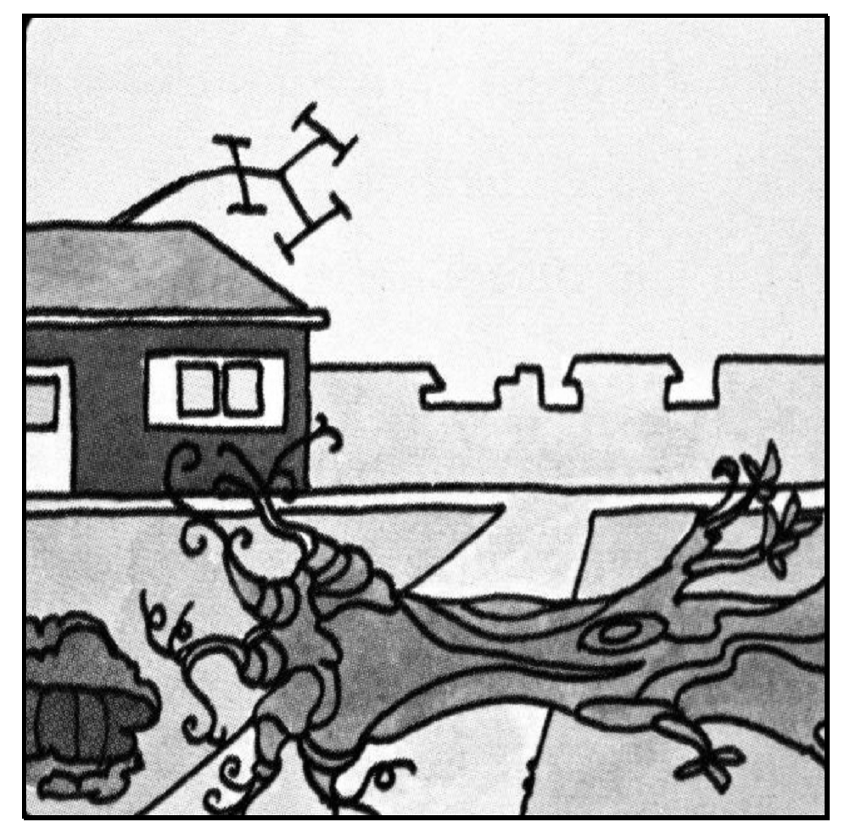 B.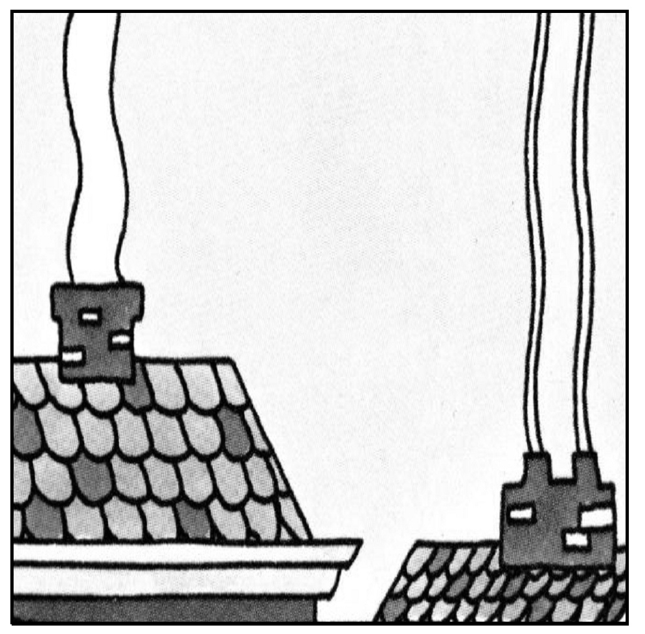

C.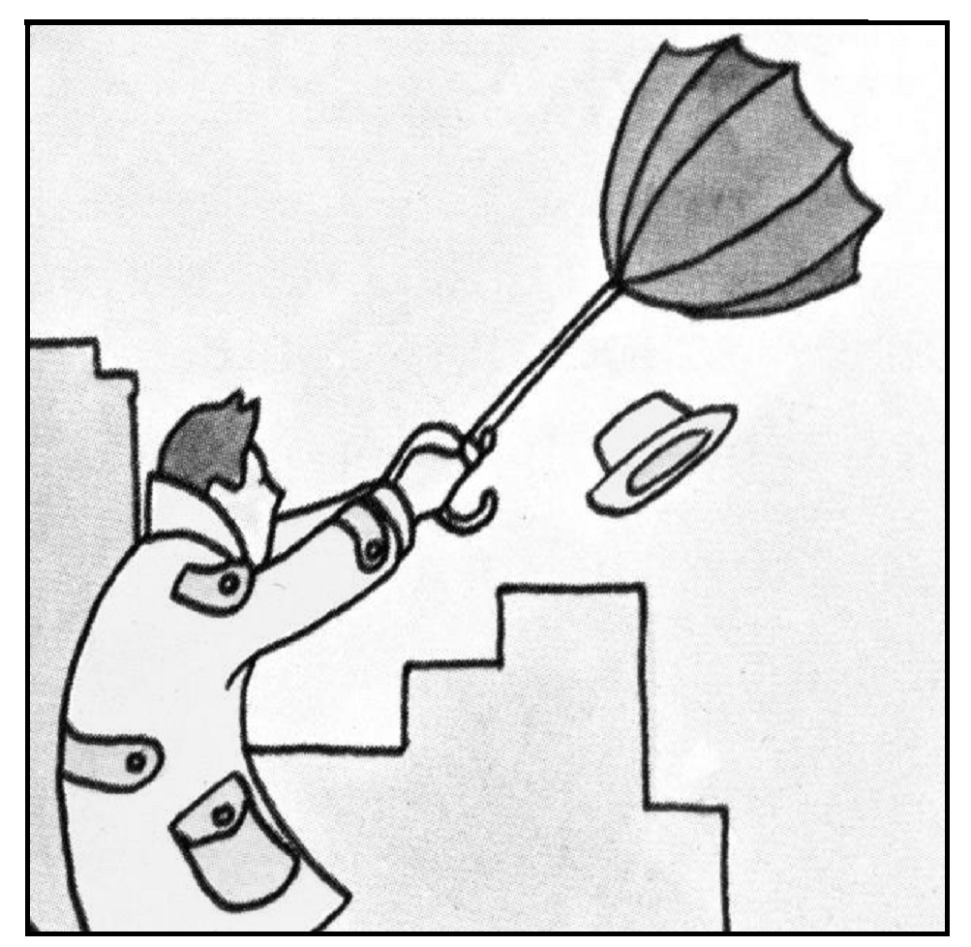 D.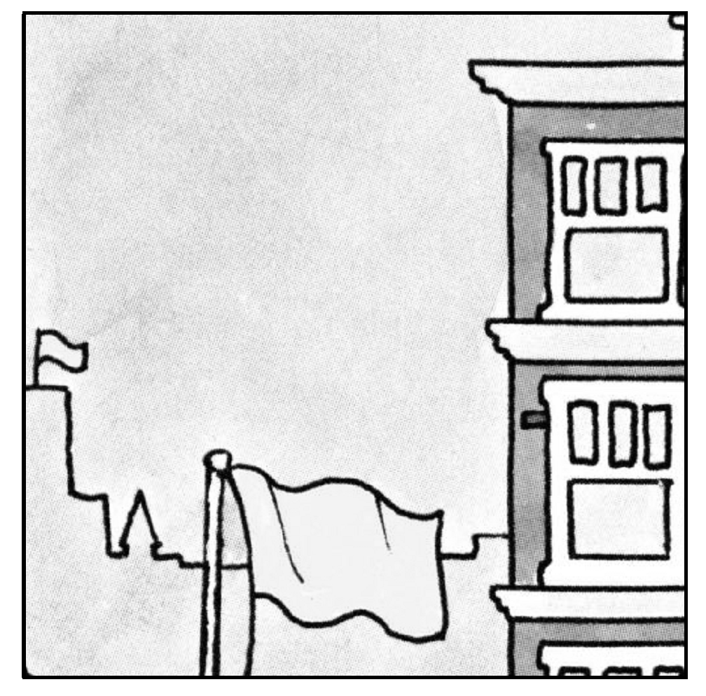
非选择题部分
四、单词拼写(本大题共8小题，每小题1分，共8分。根据下列句子及所给的单词首字母，写出各单词的完全形式,每空白处限填一词）
42. Bob is an honest person and never tells a l .
43. Changjiang is one of the longest r in the world.
44. Tomorrow is Allen’s b . He is holding a party in his house.
45. “Please h yourself to some coffee,” Rosie said to her guest.
46. Linda is much f than before, so she has decided to lose weight.
47. Katherine apologized to me because she had opened my letter by m .
48. In many countries, nobody u the age of 18 is allowed to buy cigarettes.
49. Twenty passengers on the bus s yesterday’s traffic accident; eight died, though.

五、书面表达(本大题20分)
50. 某英语报纸正举行以“感恩”为主题的征文活动。请根据下面的提示，用英语写一篇短文投稿，记述上周五上午放学后刘老师为你答疑一事，并谈谈你的感受。
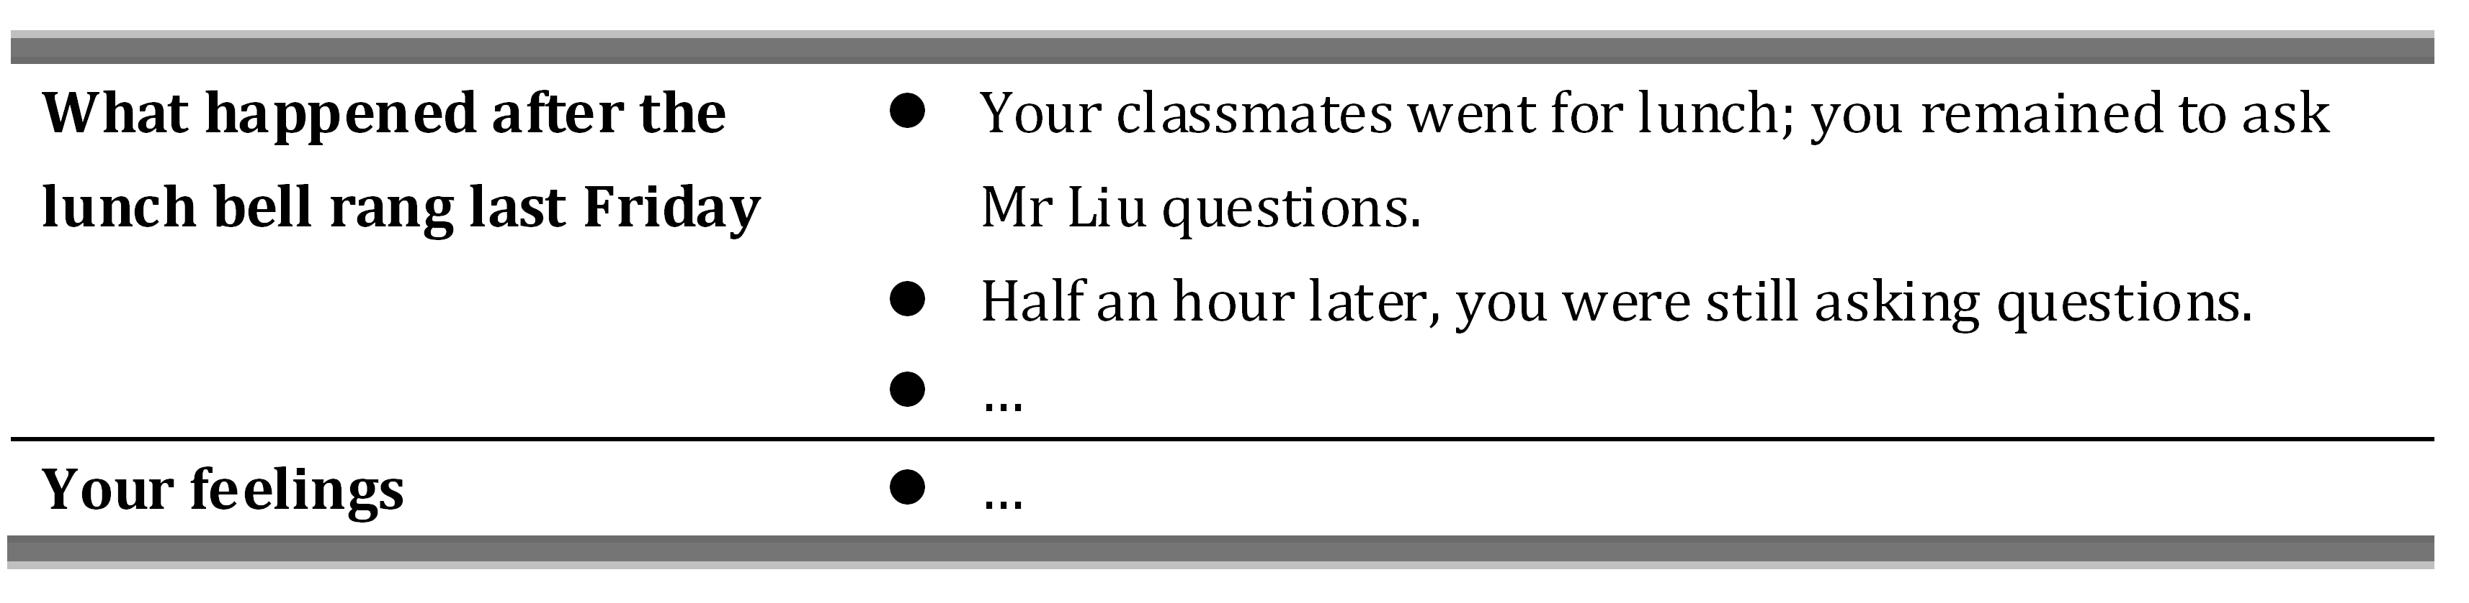
注意：（1）短文须包括上述内容，应适当增加细节，以使行文连贯；
（2）词数：100左右。开头部分已给出（不计词数）。

We have every reason to be thankful to many people around us .

答案及评分参考
一、单项填空（本大题共10小题，每小题1分，共10分。不选、多选或错选均不得分。）
1. C 2. D 3. B 4. B 5. A
6. B 7. D 8. A 9. C 10. C
二、完形填空（本大题共15小题，每小题2分，共30分。不选、多选或错选均不得分。）
11. A 12. B 13. C 14. A 15. A
16. B 17. A 18. D 19. B 20. C
21. C 22. D 23. B 24. C 25. D
三、阅读理解（本大题共16小题，每小题2分，共32分。不选、多选或错选均不得分。）
26. B 27. C 28. D 29. A 30. A
31. D 32. C 33. D 34. B 35. B
36. C 37. D 38. B 39. D 40. C
41. A
四、单词拼写（本大题共8小题，每小题1分，共8分。写对一处给1分。）
42. lie 43. rivers 44. birthday 45. help 46. Fatter
47. mistake 48. under 49. Survived
五、书面表达（本大题20分。按5个档次给分。）
50. One possible student version:
We have every reason to be thankful to many people around us. Among them is Mr Liu, a very nice math teacher of mine.
Last Friday after the lunch bell rang, my classmates went for lunch, but I remained to ask Mr Liu some questions. Half an hour later, most of my classmates came back from lunch, but I was still asking him questions, and he was so patient.
It was a small act for Mr Liu, because he is always so helpful and kind to us. However, we often take such kindness for granted. In fact, kindness is found everywhere in our life, and we should always be grateful. (98 words)
（一）评分原则
为了培养学生的创新精神和语言实践能力，促进英语写作教学，要严格按5个档次给分。既要敢于打低分，更要敢于打高分；内容和语言共计20分。在评分时，要以作文的整体谋篇和语言水平（看其是否地道）来评判。应当着重考虑考生对答疑经过的叙述和就此事件围绕“感恩”这个主题发表的简要评论，如恰当、合理，要给高分。要先确定其所属档次，然后以该档次的要求来衡量，微调得分。最后，看其词数和卷面整洁程度。如词数太少（不到80个词的）或书写欠整洁，应酌情再扣1-2分，但不倒扣分。
（二）内容要点
1．答疑经过（同学去吃中饭、“我”留下问问题、半小时后“我”还在问问题……）
2．考生的感受
（三）各档次的给分范围和要求
第五档：（16—20分）包含全部要点；语言基本无误；行文连贯，表达清楚。
第四档：（12—15分）基本包含要点，遗漏少量次要点；语言有少量错误；行文基本连贯，表达基本清楚。
第三档：（8—11分）包含部分要点；语言虽有较多错误，尚能达意。
第二档：（4—7分） 要点不明确；语言错误多，影响意思表达。
第一档：（0—3分）白卷或文不对题；错误百出，不知所云。
（四）注意
第五档有5分的差距，旨在鼓励考生写出优秀作文。请根据考生佳作把握分寸。

附录
词汇表
说明：
1．本表共收约2000个单词。
2．本词汇表不列词组和短语。
3．部分可根据构词法推导出的副词、名词等不单列。

A
a (an) art.
ability n.
able a.
about ad. & prep.
above prep., a.& ad.
abroad ad.
absent a.
accent n.
accept vt.
accident n.
according ad.
account n.
ache vi. & n.
achieve vt.
acknowledge vt.
across prep.
act n. & v.
action n.
active a.
activity n.
actor n.
actress n.
actual a.
AD/A.D. n.
add v.
address n.
admire v.
admit v.
adult n.
advance v.
advantage n.
adventure n.
advertisement (ad) n.
advice n.
advise vt.
affair n.
affect vt.
afford vt.
afraid a.
Africa n.
African a. & n.
after ad., prep. & conj.
afternoon n.
again ad.
against prep.
age n.
ago ad.
agree v.
agriculture n.
ahead ad.
aid n.
AIDS n.
aim n. & v.
air n.
airline n.
airport n.
alive a.
all ad., a. & pron.
allow vt.
almost ad.
alone a. & ad.
along ad. & prep.
aloud ad.
already ad.
also ad.
although conj.
altogether ad.
always ad.
a.m./am, A.M./AM n.
amaze v.
ambulance n.
America n.
American a. & n.
among prep.
amusement n.
and conj.
anger n.
angry a.
animal n.
announce vt.
another a. & pron.
answer n. & v.
anxious a.
any pron.
anybody pron.
anyhow ad.
anyone pron.
anything pron.
anywhere ad.
apologize vi.
apology n.
appear vi.
apple n.
application n.
appointment n.
appreciate v.
approach n. & v.
April n .
area n.
argue vi.
argument n.
arise (arose, arisen) vi.
arm n. & v.
army n.
around ad. & prep.
arrange v.
arrival n.
arrive vi.
art n.
article n.
artist n.
as ad. & conj.
ash n.
ashamed a.
Asia n.
Asian a.
ask v.
asleep a.
assistant n.
astronaut n.
at prep.
athlete n.
atmosphere n.
atom n.
attack vt.
attempt vt.
attend v.
attention n.
attitude n.
attract v.
August n.
aunt n.
Australia n.
Australian a. & n.
author n.
autumn n.
available a.
average a.
avoid v.
awake (awoke, awoken) v. & a.
award n. & vt.
away ad.

B
baby n.
back ad. a. & n.
background n.
bad (worse, worst) a.
badly (worse, worst) ad.
bag n.
baggage n.
bake v.
balance n.
ball n.
balloon n.
bamboo n.
banana n.
bank n.
bar n.
bargain n. & v.
bark v. & n.
base n.
baseball n.
basic a.
basin n.
basket n.
basketball n.
bath n.
bathe vi.
battery n.
battle n.
BC/B.C. n.
be (am, is, are, was, were, being, been) v.
beach n.
bear (bore, borne/born) v. & n.
beard n.
beast n.
beat (beat, beaten) v. & n.
beautiful a.
beauty n.
because conj.
become (became, become) v.
bed n.
bedroom n.
bee n.
beef n.
beer n.
before conj. prep. & ad.
beg v.
begin (began, begun) v.
beginning n.
behaviour n.
behind prep.& ad.
belief n.
believe v.
bell n.
belong vi.
below prep. & ad.
belt n.
bench n.
bend (bent, bent) vt.
benefit v. & n.
beside prep.
besides prep.
between prep.
beyond prep.
big a.
bike = bicycle n.
bill n.
biology n.
bird n.
birth n.
birthday n.
birthplace n.
biscuit n.
bit n., a. & ad.
bite (bit, bitten) v.
bitter a.
black n. & a.
blackboard n.
blame n. & v.
blank n. & a.
blanket n.
blind a.
block n. & vt.
blood n.
blouse n.
blow (blew, blown) v. & n.
blue n. & a.
board n. & v.
boat n.
body n.
boil v.
bone n.
book n. & v.
boring a.
born a.
borrow v.
boss n.
both a. & pron.
bother v.
bottle n.
bottom n.
bowl n.
box n.
boy n.
brain n.
branch n.
brave a.
bread n.
break (broke, broken) v.
breakfast n.
breath n.
breathe vi.
bridge n.
brief a.
bright a.
bring (brought, brought) vt.
Britain n.
British a.
broad a.
broadcast (broadcast, broadcast or -ed, -ed) vt. & n.
brother n.
brown n. & a.
brush v. & n.
bucket n.
budget n.
build (built, built) v.
building n.
burn (-ed, -ed or burnt, burnt) v. & n.
bury vt.
bus n.
bush n.
business n.
busy a.
but conj. & prep.
butter n.
button n. & v. 
buy (bought, bought) vt.
by prep.
bye int.

C
cabbage n.
café n.
cage n.
cake n.
call n. & v.
calm a.
camera n.
camp n. & vi.
can¹ (could) modal v.
can² n.
Canada n.
Canadian a.
candle n.
cap n.
capital n.
captain n.
car n.
card n.
care n.
career n.
careful a.
careless a.
carpet n.
carrot n.
carry vt.
cartoon n.
case n.
castle n.
cat n.
catch (caught, caught) v.
cattle n.
cause n. & vt.
cave n.
ceiling n.
celebrate v.
cent n.
central a.
centre (AmE center ) n.
century n.
certain a.
certainly ad.
chain n.
chair n.
chairperson n.
chalk n.
challenge n.
chance n.
change n. & v.
character n.
chapter n.
chat n. & vi.
cheap a.
check n.
cheer n. & vi.
cheese n.
chemical a. & n.
chemistry n.
cheque (AmE check) n.
chest n.
chicken n.
chief a. & n.
child (pl. children) n.
China n.
Chinese a. & n.
chocolate n.
choice n.
choose (chose, chosen) vt.
Christmas n.
church n.
cigarette n.
cinema n.
circle n. & vt.
citizen n.
city n.
class n.
classmate n.
classroom n.
clean vt. & a.
clear a.
clerk n.
clever a.
climate n.
climb v.
clinic n.
clock n.
close a. & ad.
cloth n.
clothes n.
clothing n.
cloud n.
club n.
coal n.
coast n.
coat n. & vt.
cock n.
coffee n.
coin n.
cold a. & n.
collect vt.
college n.
colour (AmE color) n. & vt.
comb n. & v.
come (came, come) vi.
comfort n.
comfortable a.
comment n. & v.
common a.
communicate v.
communication n.
community n.
companion n.
company n.
compare vt.
compete v.
complete a. & vt.
composition n.
computer n.
concert n.
conclusion n.
condition n.
conductor n.
congratulation n.
connect vt.
consider vt.
construction n.
contain v.
content a. & n.
continent n.
continue vi.
contribution n.
control vt. & n.
convenient a.
conversation n.
cook n.
cool a.
copy n.
corn n.
corner n.
correct v. & a.
correction n.
cost (cost, cost) v. & n.
cottage n.
cotton n. & a.
cough n. & vi.
could modal v.
count vt.
counter n.
country n.
couple n.
courage n.
course n.
courtyard n.
cousin n.
cover n.
cow n.
crash n. & v.
crazy a.
create v.
crop n.
cross n. & vt.
crowd n. & vt.
cruel a.
cry n. & v.
culture n.
cup n.
cupboard n.
curiosity n.
curious a.
current a.
curtain n.
custom n.
customer n.
cut (cut, cut) v. & n.

D
dad = daddy n.
daily a., ad. & n.
damage n.& vt.
damp a. & n.
dance n.& vi.
danger n.
dangerous a.
dare v.& v. aux.
dark n. & a.
data n.
date n.
daughter n.
dawn n.
day n.
dead a.
deal n.
dear a. & int.
death n.
debt n.
decision n.
December n.
decide v.
decorate vt.
deed n.
deep a. & ad.
deeply ad.
deer n.
defeat vt.
defence (AmE defense) n. & v.
defend vt.
degree n.
delay v. & n.
delicious a.
delight v. & n.
delighted a.
deliver vt.
demand vt.
dentist n.
department n.
depend vi.
describe vt.
description n.
desert¹ n.
desert² vt.
design n. & vt.
desire vt. & n.
desk n.
destroy vt.
detail n.
determine vt.
develop v.
devote vt.
dial vt.
dialogue (AmE dialog) n.
diamond n.
diary n.
dictation n.
dictionary n.
die v.
difference n.
different a.
difficult a.
difficulty n.
dig (dug, dug) v.
dining-room n.
dinner n.
direct a. & vt.
direction n.
director n.
dirty a.
disagree vi.
disappear vi.
disaster n.
discover vt.
discovery n.
discuss vt.
discussion n.
disease n.
dish n.
distance n.
distant a.
district n.
disturb vt.
dive vi.
divide vt.
do (did, done) v. & v. aux.
doctor n.
dog n.
dollar n.
door n.
double a. & n.
doubt n.& v.
down prep. & ad.
downtown ad. & n.
dozen n.
draw (drew, drawn) v.
dream (dreamt, dreamt or -ed, -ed) n.& vt.
dress n. & v.
drill n. & vt.
drink (drank, drunk) v. & n.
drive (drove, driven) v.
drop n. & v.
drown vi.
drug n.
dry v. & a.
duck n.
dull a.
during prep.
dust n.
duty n.
DVD (digital video disk) n.

E
each a. & pron.
eager a.
ear n.
early a. & ad.
earn vt.
earth n.
east a., ad. & n.
eastern a.
easy a.
eat (ate, eaten) v.
economy n.
edge n.
education n.
effect n.
efficient a.
effort n.
egg n.
eight num.
eighteen num.
eighth num.
eighty num.
either a., pron. & ad.
elder n.
electric a.
electricity n.
elephant n.
eleven num.
else ad.
e-mail/email n. & v.
employ vt.
empty a. & vt.
encourage vt.
end n. & v.
enemy n.
energy n.
engineer n.
England n.
English a. & n.
enjoy vt.
enormous a.
enough n., a. & ad.
enter vi. & vt.
entire a.
entrance n.
envelope n.
environment n.
equal a. & vt.
equipment n.
eraser n.
escape n. & vi.
especially ad.
Europe n.
European a. & n.
eve n.
even ad.
evening n.
event n.
eventually ad.
ever ad.
every a.
everybody pron.
everyone pron.
everything pron..
everywhere ad.
exact a.
exam = examination n.
examine vt.
example n.
excellent a.
except prep.
excite vt.
excuse n. & vt.
exercise n. & vi.
exhibition n.
exist vi.
expect vt.
expensive a.
experience n.
experiment n.
explain vt. & vi.
explanation n.
explode v.
express vt. & n.
expression n.
extra a.
extremely ad.
eye n.
eyesight n.

F
face n. & vt.
fact n.
factory n.
fail v.
fair a.
fairly ad.
faith n.
fall n. & vi.
false a.
familiar a.
family n.
famous a.
fan n.
far (farther, farthest or further, furthest) a.& ad.
farm n.
farmer n.
fashion n.
fashionable a. & ad.
fast a. & ad.
fat n. & a.
father n.
fault n.
favour (AmE. favor) n.
favourite (AmE favorite) a. & n.
fear n. &v.
feather n.
February n.
feed (fed, fed) vt.
feel (felt, felt) v.
feeling n.
fellow n.
fence n.
festival n.
fetch vt.
fever n.
few pron. & a.
field n.
fierce a.
fifteen num.
fifth num.
fifty num.
fight (fought, fought) v. & n.
figure n.
file n.
fill vt.
film n. & vt.
final a.
find (found, found) vt.
fine a., n.& v.
finger n.
finish v.
fire n. & vi.
firm n. & a.
first num., a. & ad.
fish n. & vi.
fist n.
fit a. & v.
five num.
fix vt.
flag n.
flash n.
flat a. & n.
flight n.
float vi.
flood n. & vt.
floor n.
flour n.
flow vi.
flower n.
fly (flew, flown) v. & n.
focus n. & v.
fold n. & vt.
follow v.
fond a.
food n.
fool n. & vt.
foolish a.
foot (pl. feet) n.
football n.
for prep. & conj.
force vt. & n.
foreign a.
forest n.
forever ad.
forget (forgot, forgot /forgotten) v.
forgive (forgave, forgiven) vt.
fork n.
form n.
formal a.
fortnight n.
fortunate a.
forty num.
forward ad.
found vt.
four num.
fourteen num.
fourth num.
fox n.
France n.
free a.
freedom n.
freeze (froze, frozen) vi.
French n. & a.
Frenchman (pl. Frenchmen) n.
Frenchwoman (pl. Frenchwomen)
frequent a.
fresh a.
Friday n.
fridge = refrigerator n.
friend n.
friendly a.
friendship n.
frighten vt.
from prep.
front a. & n.
fruit n.
fry vt. & n.
fuel n.
full a.
fun n.
funny a.
fur n.
furniture n.
future n.

G
gain vt.
game n.
garage n.
garden n.
gas n.
gate n.
gather v.
general a.
generation n.
gentle a.
gentleman (pl. gentlemen) n.
geography n.
German a. & n.
Germany n.
get (got, got) v.
gift n.
girl n.
give (gave, given) vt.
glad a.
glass n.
glove n.
go (went, gone) vi.
goal n.
goat n.
god n.
gold n.
golden a.
good (better, best) a.
good-bye int.
goods n.
government n.
grade n.
gradually ad.
graduate v. & n.
grain n.
grammar n.
grandchild n. (pl. grandchildren)
grandparent n.
grass n.
grateful a.
great a. & ad.
Greek a. & n.
green a. n.
greet vt.
greeting n.
grey (AmE gray) a.
grocery n.
ground n.
group n.
grow (grew, grown ) v.
grown-up n. & a.
guard n. & vt.
guess vi. & n.
guest n.
guide n.
gun n.

H
habit n.
hair n.
half （pl. halves） a.& n.
hall n.
hammer n. & v.
hand n. & v.
handsome a.
hang(hanged, hanged) v.
hang (hung, hung) v.
happen vi.
happy a.
hard ad. & a.
hardly ad.
hard-working a.
harvest n.& vt.
hat n.
hate vt. & n.
have (had, had) v. & aux. v.
he pron.
head n., a. & v.
headache n.
headmaster / headmistress n.
health n.
hear (heard, heard) v.
heart n.
heat n. & vt.
heaven n.
heavy a.
height n.
hello int.
help n. & vt.
her pron.
here ad.
hero n.
hers pron.
herself pron.
hi int.
hide (hid, hidden/hid) v.
high a. & ad.
hill n.
him pron.
himself pron.
hire vt.
his pron.
history n.
hit (hit, hit) n. & vt.
hobby n.
hold (held, held) vt.
hole n.
holiday n.
home n. & ad.
homework n.
honest a.
honour (AmE honor) n. & vt.
hope n.& v.
hopeless a.
horse n.
hospital n.
host n. & v.
hot a.
hotel n.
hour n.
house n.
housewife n.
housework n.
how ad.
however ad. & conj.
huge a.
human a.
hundred num.
hunger n.
hungry a.
hurry vi.
hurt (hurt, hurt) vt.
husband n.

I
I pron.
ice n.
idea n.
if conj.
ill (worse, worst) a.
illness n.
imagine vt.
immediately ad.
importance n.
important a.
impossible a.
improve vt.
in prep. & ad.
inch n.
include vt.
income n.
increase v. & n.
indeed ad.
independent a.
India n.
Indian n. & a.
individual n. & a.
industry n.
infer v.
influence n. & v.
informal a.
information n.
ink n.
inside prep. & ad.
insist vi.
inspire vt.
instead ad.
institute n.
instruction n.
intend v.
interest n.
interesting a.
international a.
Internet n.
interpreter n.
interrupt v.
interview v.
into prep.
introduce vt.
invent vt.
invite vt.
iron n.
island n.
issue v. & n.
it pron.
its pron.
itself pron.

J
jacket n.
jam n.
January n.
Japan n.
Japanese a. & n.
jar n.
job n.
join v.
joke n.
journal n.
journey n.
joy n.
judge n. & vt.
juice n.
July n.
jump n. & v.
June n.
just ad. & a.

K
keep (kept, kept) v.
key n.
kick v. & n.
kid n.
kill v.
kilo n.
kilometre/kilometer (km) n.
kind n. & a.
king n.
kingdom n.
kiss n.& vt.
kitchen n.
kite n.
knee n.
knife (pl. knives) n.
knock n. & v.
know (knew, known) v.
knowledge n.

L
lab = laboratory n.
labour (AmE labor) n.
lack n. & vt.
lady n.
lake n.
lamp n.
land n. & v.
language n.
large a. & n.
last a., ad., n. & v.
late a. & ad.
lately ad.
later a.
laugh n. & v.
law n.
lawyer n.
lay (laid, laid) vt.
lazy a.
lead (led, led) v.
leader n.
leaf (pl. leaves) n.
League member
learn (learnt, learnt; -ed, -ed) vt.
least n.
leave (left, left) v.
lecture n.
left a., ad. & n.
leg n.
leisure n.
lend (lent, lent) vt.
length n.
less a.& ad.
lesson n.
let (let, let) vt.
letter n.
level n.
library n.
license n.
lie n. & vi.
life (pl. lives) n.
lifetime n.
lift v. & n.
light n., vt. & a.
lightning n.
like prep. & vt.
likely a.
limit vt.
line n. & v.
link v.
lion n.
lip n.
list n.
listen vi.
litre (AmE liter) n.
little (less, least) a., ad. & n.
live vi.
lively a.
load n.
local a.
lock n. & vt.
lonely a.
long a. & ad.
look n. & v.
lorry n.
lose (lost, lost) vt.
lot n.
loud a.
love n.& vt.
lovely a.
low a.& ad.
luck n.
luggage n.
lunch n.

M
machine n.
mad a.
madam/ Madame n.
magazine n.
mail n. & v.
main a.
major a.
majority n.
make (made, made) vt.
male a.
man (pl. men) n.
manage v.
manager n.
many (more, most) pron. & a.
map n.
march n.
March n.
mark n. & vt.
market n.
marriage n.
marry v.
marvelous a.
mask n. & v.
master vt.
match n. & vt.
material n.
math = maths/mathematics n.
matter n. & vi.
may modal v.
May n.
maybe ad.
mayor n.
me pron.
meal n.
mean (meant, meant) vt.
meaning n.
measure v.
meat n.
media n.
medical a.
medicine n.
meet (met, met) vt. & n.
meeting n.
member n.
memory n.
mend v.
mental a.
mention n. & vt.
menu n.
merry a.
message n.
metal n. & a.
method n.
metre (AmE meter) n.
middle n.
midnight n.
might modal v.
mild a.
mile n.
milk n. & vt.
million num.
mind n. & v.
mine pron.
minor n.
minute n.
mirror n.
miss vt.
Miss n.
mistake (mistook, mistaken) n. & vt.
mix v.
mobile a.
model n.
modern a.
moment n.
Monday n.
money n.
monitor n.
monkey n.
month n.
moon n.
more a., ad. & n.
morning n.
most a., ad.& n.
mother n.
mountain n.
mouse (pl. mice) n.
mouth n.
move v.
movement n.
movie n.
Mr. (mister) n.
Mrs. (mistress) n.
Ms. n.
much (more, most) a., ad. & pron.
multiply vt.
mum n.
murder vt.
museum n.
music n.
must modal v.
my pron.
myself pron.

N
nail n.
name n. & vt.
narrow a.
nation n.
national a.
nationality n.
native a.
natural a.
nature n.
near a., ad. & prep.
nearby a.
nearly ad.
neat a.
necessary a.
neck n.
need n., v. & modal v.
needle n.
negative a.
neighbour (AmE neighbor) n.
neither a.
nervous a.
net n.
never ad.
new a.
news n.
newspaper n.
next a., ad. & n.
nice a.
night n.
nine num.
nineteen num.
ninety num.
ninth num.
no ad. & a.
nobody pron.
nod vi.
noise n.
noisy a.
none pron.
noon n.
nor conj.
normal n. & a.
north a., ad. & n.
northern a.
nose n.
not ad.
note n. & vt.
nothing pron.
notice n. & vt.
November n.
now ad.
nowadays ad.
nowhere ad.
nuclear a.
number n.
nurse n.
nut n.

O
obey v.
object n.
obviously ad.
ocean n.
o'clock n.
October n.
of prep.
off prep. & ad.
offer n. & vt.
office n.
officer n.
official n. & a.
often ad.
oh int.
oil n.
OK ad.
old a.
on prep. & ad.
once n., ad. & conj.
one pron. & num.
oneself pron.
only a. & ad.
onto prep.
open a. & vt.
operate v.
operation n.
opinion n.
opportunity n.
opposite n. & a.
or conj.
orange n. & a.
order n. & vt.
ordinary a.
organization (AmE organisation) n.
organize (AmE organise) vt.
other pron. & a.
otherwise ad.
ought modal v.
our pron.
ours pron.
ourselves pron.
out ad.
outdoors ad.
outside n., ad. & prep.
over prep. & ad.
overcoat n.
own a. & v.

P
pack n. & v.
page n.
pain n.
paint n. & vt.
painting n.
pair n.
palace n.
pale a.
pan n.
paper n.
pardon n.
parent n.
park n. & vt.
part n., a. & v.
particular adj.
partly ad.
party n.
pass vt.
passage n.
passenger n.
passer-by n. (pl. passers-by)
past ad., n. & prep.
path n.
patient n. & a.
pattern n.
pause n. & vi.
pay (paid, paid) v.
peace n.
peaceful a.
pear n.
pen n.
pencil n.
penny (pl. pennies or pence) n.
people n.
per prep.
percent n.
perfect a.
perform v.
performance n.
perhaps ad.
period n.
permit vt. & n.
person n.
personal a.
persuade vt.
pet n.
phone = telephone v.
photo =photograph n.
physical a.
physics n.
piano (pl. pianos) n.
pick v.
picnic n. & v.
picture n.
pie n.
piece n.
pig n.
pile n.
pillow n.
pilot n.
pink a.
pioneer n.
pipe n.
pity n.
place n. & v.
plain a. & n.
plan n.& v.
plane n.
planet n.
plant vt. & n.
plastic a.
plate n.
platform n.
play v. & n.
player n.
playground n.
pleasant a.
please v.
pleased a.
pleasure n.
plenty n.
p.m./pm, P.M. /PM n.
pocket n.
poem n.
poet n.
point v. & n.
pole n.
police n.
policeman (pl.-men)/ policewoman (pl. -women) n.
policy n.
polite a.
political a.
politics n.
pollute v.
pollution n.
pool n.
poor a.
popular a.
population n.
pork n.
port n.
position n.
positive a.
possession n.
possible a.
possibly ad.
post n. & v.
postcard n.
pot n.
potato (pl. potatoes) n.
pound n.
pour vi.
power n.
practical a.
practice n. & v.
praise  n.& vt.
precious a.
prefer vt.
prepare vt.
present a. & vt.
president n.
press n.
pretend vi.
pretty a.
prevent vt.
previous adj.
price n.
pride n.
print vt.
prison n.
prisoner n.
private a.
prize n.
probably ad.
problem n.
process n. & vt.
produce vt.
product n..
production n.
professor n.
profit n.
programme (AmE program) n.
progress n. & vi.
project n.
promise n.& vi.
pronounce vt.
pronunciation n.
proper a.
propose v.
protect vt.
proud a.
prove v.
provide vt.
public a. & n.
pull v. & n.
pump vt.
punish v.
pupil n.
pure a.
purpose n.
purse n.
push n. & v.
put (put, put) vt.
puzzle n. & v.

Q
quality n.
quantity n.
quarrel vi.
quarter n.
queen n.
question vt. & n.
queue n. & v.
quick a. & ad.
quiet a.
quite ad.
quiz n.

R
race n. & v.
radio n.
rail n.
railway n.
rain n. & vi.
raincoat n.
raise vt.
rapid a.
rather ad.
ray n.
reach v.
read (read, read) v.
ready a.
real a.
realize (AmE realise) vt.
really ad.
reason vi. & n.
receive v.
recent a.
recognise (AmE recognize) vt.
record n. & v.
recover vi.
red n. & a.
reduce vt.
refer v.
refuse vi.
regard v. & n.
regret n. & vt.
regular a.
relate vi.
relationship n.
relative n.
rely v.
remain v.
remember v.
remind vt.
remove vt.
repair n.& vt.
repeat vt.
reply v. & n.
report n.& v.
represent vt.
republic n.
request n.
require vt.
research n.
resource n.
respect vt. & n.
responsible a.
rest n. & vi.
restaurant n.
result n.
return n.& v.
review vt. & n.
rice n.
rich a.
ride (rode, ridden) v. & n.
right n., a., ad. & a.
ring (rang, rung) v. & n.
ripe a. .
rise (rose, risen) vi.
risk n, & v.
river n.
road n.
rock n. & vt.
role n.
roll v. & n.
roof n.
room n.
root n.
rose n.
round ad., prep. & a.
row n. & v.
rubber n.
rubbish n.
rude a.
ruin vt. & n.
rule n. & vt.
ruler n.
rumour (AmE rumor) n.
run (ran, run) vi.
rush vi.
Russia n.
Russian a. & n.

S
sad a.
safe a. & n.
safety n.
sail n. & v.
sailor n.
sale n.
salt n.
same n.
sand n.
sandwich n.
satisfaction n.
satisfy vt.
satellite n.
Saturday n.
save vt.
say (said, said) vt.
scene n.
school n.
science n.
scientific a.
scientist n.
score n. & v.
scream n. & v.
sea n.
search n. & v.
season n.
seat n.
second n., num. & a.
second-hand a. & ad.
secret n.
secretary n.
see (saw, seen) vt.
seed n.
seem v.
seldom ad.
select vt.
selfish a.
sell (sold, sold) v.
send (sent, sent) v.
senior a. & n.
sense n.
sentence n.
separate v. & a.
September n.
serious a.
servant n.
serve vt.
service n.
set n. & vt.
settle v.
seven num.
several pron. & a.
sex n.
shade n.
shadow n.
shake (shook, shaken) v.
shall (should) modal v.
shame n.
shape n. & v.
share vt.
sharp a.
shave (shaved, shaved或shaven) v.
she pron.
sheep (pl. sheep) n.
sheet n.
shelf (pl. shelves) n.
shine (shined/shone, shined/shone) v.
ship n. & vi.
shirt n.
shock vt.
shoe n.
shoot n. & vt.
shop vi. & n.
shore n.
short a.
should v. aux.
shoulder n.
shout n. & v.
show (showed, shown 或 showed) v. & n.
shower n.
shut (shut, shut) v. & n.
shy a.
sick a.
side n.
sigh vi.
sight n.
sign n.
silence n.
silent a.
silk n.
silly a.
silver n.
similar a.
simple a.
since ad., conj. & prep.
sing (sang, sung) v.
single a.
sink (sank, sunk) vi.
sir n.
sister n.
sit (sat, sat) vi.
situation n.
six num.
sixteen num.
sixth num.
sixty num.
size n.
skill n.
skin n.
skirt n.
sky n.
slave n.
sleep (slept, slept) vi. & n.
slight a.
slow ad.
small a.
smart a.
smell (smelt, smelt 或 smelled, smelled) v. & n.
smile n. & v.
smoke n. & v.
smooth a.
snake n. & v.
snow n. & vi.
so ad. & conj.
soap n.
social a.
society n.
sock n.
soft a.
software n.
soil n.
soldier n.
some a. & pron.
somebody pron.
someone pron.
something pron.
sometimes ad.
somewhere ad.
son n.
song n.
soon ad.
sorry a.
sort vt. & n.
sound vi. & n.
soup n.
south a. ad. & n.
southern a.
space n.
Spanish a. & n.
spare v. & a.
speak (spoke, spoken) v.
special a.
speech n.
speed (sped, sped) v & . n.
spell (spelled/spelt, spelled/spelt) vt.
spend (spent, spent) v.
spirit n.
splendid a.
spoon n.
sport n.
spot n. & v.
spread v.
spring n.
square n. & a.
stage n.
stair n.
stamp n.
stand (stood, stood) v.
standard n. & a.
star n.
stare vi.
start v.
state n.
statement n.
station n.
stay n. & vi.
steal (stole, stolen) vt.
steel n.
step n. & vi.
stick (stuck, stuck) vi. & n.
still a. & ad.
stomach n.
stone n.
stop n. & v.
store n. & vt.
storm n.
story n.
straight a. & ad.
strange a.
stranger n.
street n.
strict a.
strong a.
struggle vi.
student n.
study v. & n.
stupid a.
subject n.
succeed vi.
success n.
such pron. & a.
suddenly ad.
suffer vi.
sugar n.
suggest vt.
suit vt. & n.
suitable a.
suitcase n.
summer n.
sun n.
Sunday n.
sunny a.
supper n.
supply vt. & n.
support vt. & n.
suppose vt.
sure a.
surely ad.
surface n.
surprise vt. & n.
survey n. & vt.
survive vt.
sweater n.
sweep (swept, swept) v.
sweet n. & a.
swim (swam, swum) n. & v.
system n.

T
table n.
tail n.
tailor n.
take (took, taken) vt.
tale n.
talk n.& v.
tall a.
tap n. & v.
tape n.
task n.
taste n. & vt.
tax n.
taxi n.
tea n.
teach (taught, taught) v.
teacher n.
team n.
tear (tore, torn) n. & v.
technical a.
technique n.
technology n.
teen n. & a.
teenager n.
telephone v. & n.
television (TV) n.
tell (told, told) vt.
temperature n.
ten num.
tend v.
tense a. & n.
tent n.
term n.
terrible a.
terrify vt.
test vt. & n.
text n.
than conj.
thank vt. & n.
that a., pron., conj. & ad.
the art.
theatre / theater n.
their pron.
theirs pron.
them pron.
themselves pron.
then ad.
there int., n. & ad.
therefore ad.
these  a. & pron.
they pron.
thick a.
thief (pl. thieves) n.
thin a.
thing n.
think (thought, thought) v.
thinking n.
third num.
thirsty a.
thirteen num.
thirty num.
this  a. & pron.
those  a. & pron.
though conj.
thought n.
thousand num.
thread n.
threaten v.
three num.
through prep. & ad.
throw (threw, thrown) v.
Thursday n.
thus ad.
ticket n.
tidy a.
tie vt.
tiger n.
tight a.
till conj.& prep.
time n. & vt.
tiny a.
tip n.& v.
tire vi.
tired a.
title n.
to prep.
today ad. & n.
together ad.
toilet n.
tomato n.
tomorrow  ad. & n.
ton n.
tongue n.
tonight ad. & n.
too ad.
tool n.
tooth (pl. teeth) n.
top n.
topic n.
total a., n. & v.
touch vt.
tough a.
tour n.
toward(s) prep.
town n.
toy n.
track n. & v.
trade n. & vt.
tradition n.
traffic n.
train n. & v.
training n.
transfer v. & n.
translate vt.
transport n. & vt.
transportation n.
travel n. & vi.
travel(l)er n.
treasure n.
treat vt.
tree n.
trick n.
trip n.
trouble vt. & n.
trousers (pl.) n.
truck n. & v.
true a.
trust vt.
truth n.
try v.
Tuesday n.
turn n. & v.
twelfth num.
twelve num.
twentieth num.
twenty num.
twice ad.
two num.
type vt.
typical n.
tyre (AmE tire) n.

U
ugly a.
umbrella n.
uncle n.
under ad. & prep.
understand (understood, understood) v.
uniform n.
union n.
unit n.
unite v.
united adj.
universe n.
university n.
unknown a.
unless conj.
until prep. & conj.
unusual a.
up ad., a., n. & prep.
upon prep.
upper a.
upset a.
upstairs ad.
upward(s) ad.
us pron.
use  n. & vt.
used a.
useful a.
usual a.
usually ad.

V
vacation n.
valuable a.
value n.
various a.
vast a.
vegetable n.
vehicle n.
very ad. & a.
victory n.
view n.
village n.
violin n.
visit n.& vt.
visitor n.
voice n.
volleyball n.
voyage n.

W
wait vi.
waiter n.
waitress n.
wake (woke, woken) v.
walk n. & v.
wall n.
want vt.
war n.
warm a.
warn vt.
wash n. & v.
waste n.& vt.
watch vt. & n.
water n. & v.
wave n. & v.
way n.
we pron.
weak a.
weakness n.
wealth n.
wear (wore, worn) v.
weather n.
web n.
wedding n.
Wednesday n.
week n.
weekend n.
weigh vt.
weight n.
welcome int., n., v. & a.
well (better, best) a., ad., int. & n.
well-known a.
west a.
western a.
wet a.
what pron. & a.
whatever conj. & pron.
wheat n.
wheel n.
when conj. & ad.
whenever conj.
where ad.
wherever conj.
whether conj.
which pron. & a.
while conj. & n.
whisper v. & n.
white a. & n.
who pron.
whoever pron.
whole a.
whom pron.
whose pron.
why ad. & int.
wide a.
wife (pl. wives) n.
wild a.
will (would) modal v. & n.
willing a.
win (won, won) n.
wind¹ n. 
wind² (wound, wound) vt.
window n.
wine n.
wing n.
winter n.
wire n.
wisdom n.
wise a.
wish n. & vt.
with prep.
within prep.
without prep.
wolf (pl. wolves) n.
woman ( pl. women) n.
wonder v. & n.
wonderful a.
wood n.
wooden a.
wool n.
word n.
work n. & vi.
worker n.
workshop n.
world n.
worry n. & v.
worth a.
would modal v.
wound vt. & n.
write (wrote, written) v.
wrong a.

Y
yard n.
year n.
yellow a.
yes ad.
yesterday n. & ad.
yet ad.
you pron.
young a.
your pron.
yours pron.
yourself (pl. yourselves) pron..
youth n.

Z
zero n. & num.
zoo n.

